MONTHLY AFRICA CLIMATE REPORT - MARCH 2019

The following analyses document recent climate conditions, their unusualness, and their long-term trends for a broader swath of the climate system, drawn from WMO global data Centres, data from ACMAD partners, and regional dataand analysis for Africa from Regional Centers and National Meteoological and Hydrological Services . Because most African data are available late, these reports are often released about the tenth of the following month.
- Africa. Analysis
A monthly overview of recent and current climate conditions across the United States. The report focuses on the latest complete month and draws from the other U.S. focused monthly reports (see below) and monitoring products. Analyses place climate conditions and significant events into historical perspective.
- Synoptic Discussion
The Synoptic Discussion provides a detailed discussion of the major atmospheric patterns that occurred during the month, and how these relate to the phenomena that cause weather such as the jet stream and the position of ridges and troughs. The discussion also relates these patterns to known drivers on climate variability time scales such as El Niño / La Niña and the Arctic Oscillation. The discussion is somewhat technical and assumes familiarity with meteorological terminology.
- Floods
The Tornadoes report provides a large-scale overview of the occurrence of tornadoes across the country for a given month as well as a running analysis of the current tornado season. It draws heavily on data from and coordination with NOAA’s Storm Prediction Center. It is produced monthly during the most active tornado months (March through September) and may be produced during the less active months, if conditions warrant.
- Drought
The U.S. Drought report compiles information from a wide array of drought indicators. Because drought is a complex process that affects different people in different ways, there are many ways to characterize drought and many metrics used by decision makers as “triggers” for drought action. Because of this, the drought report tends to be the most detailed and lengthy of all the Monthly Climate Reports.
- Heat and cold waves
This report provides large-scale information on the number and coverage of wildfires during the month and the fire-weather conditions that shaped outcomes. Selected significant wildfire events and episodes are briefly addressed when possible. This report is updated monthly.
- Onset/withdrawal of seasonal precipitation
- dry and wet spells
- Breaks and Bursts in the monsoon
- U.S. Snow and Ice
The U.S. Snow and Ice report broadly covers the state of snow cover and winter weather over the course of the cold season. Snow cover extent and snow depth measurements are compared to long-term averages and trends. Significant winter weather events are documented and placed into historical perspective. This report draws upon information from the Rutgers Snow Lab and other NOAA sources. It is updated October through April.
- Storms ( focus on south west indian ocean)
This report puts the current Tropical Cyclone season into a climate perspective. Brief summaries of individual storms are provided. This report is not nearly as comprehensive or timely as those available from NOAA’s National Hurricane Center. It is updated monthly during tropical cyclone season (typically June through November, although storms sometimes occur outside these months).
- Teleconnections (https://www.ncdc.noaa.gov/teleconnections/ )
Spatially and temporally large-scale anomalies that influence the variability of the atmospheric circulation
- Arctic Oscillation (AO)
Information on the Arctic Oscillation (AO), a large scale mode of climate variability, also referred to as the Northern Hemisphere annular mode.
- El Niño/Southern Oscillation (ENSO)
Information on the El Nino Southern Oscillation (ENSO), a periodic fluctuation in sea surface temperature and air pressure in the equatorial Pacific Ocean.
  - Sea Surface Temperatures (SST)
SST anomalies for several commonly-known ENSO regions
  - Outgoing Longwave Radiation (OLR)
This OLR product is a proxy for convective precipitation in the western equatorial Pacific
  - Southern Oscillation Index (SOI)
Information on the Southern Oscillation Index (SOI), a standardized index based on the observed sea level pressure differences between Tahiti and Darwin, Australia.
  - Sea Level Anomalies
  - TAO/Triton Data Display
- North Atlantic Oscillation (NAO)
Information on the North Atlantic Oscillation (NAO) index, which is based on the surface sea-level pressure difference between the Subtropical (Azores) High and the Subpolar Low.
- Pacific Decadal Oscillation (PDO)
Information on the Pacific Decadal Oscillation (PDO), often described as a long-lived El Nino-like pattern of Pacific climate variability.
- Pacific-North America Index (PNA)
Information the Pacific-North America (PNA) pattern, one of the most prominent modes of low-frequency variability in the Northern Hemisphere extratropics, appearing in all months except June and July.

- Significant events during the month of March (Sample)
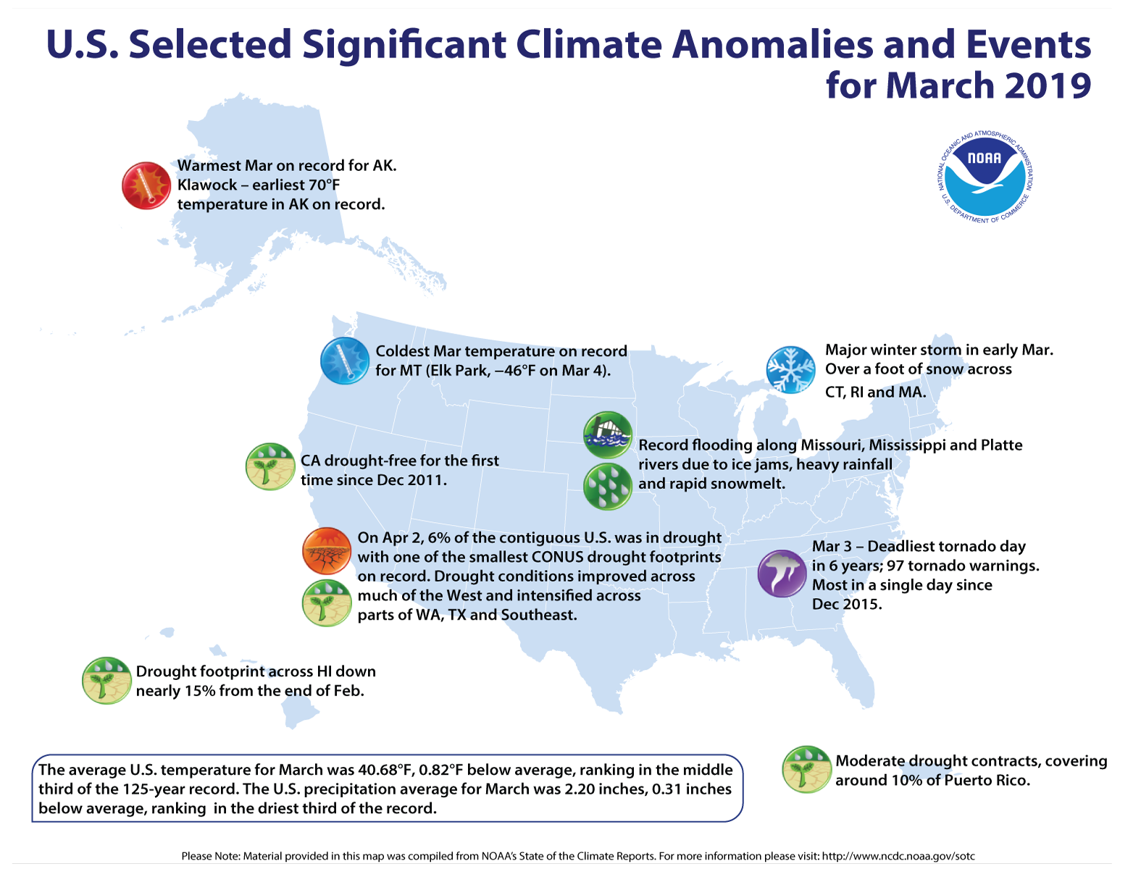

Climate Monitoring at NOAA's National Centers for Environmental Information is committed to the monitoring and assessment of the state of the Earth's climate in near real-time, providing decision-makers at all levels of the public and private sectors with data and information on climate trends and variability.
- National
- Global
- 1-Month
- 3-Month
- Year-to-Date
March 2019
Contiguous U.S. | Value | Anomaly* | Rank† | Decadal Trend
 |  | *1901-2000 | †Out of 124
Average Temperature | 40.68°F | -0.82°F | 44th Coolest | +0.25°F
Precipitation | 2.2" | -0.31" | 34th Driest | +0.01"

Climate Monitoring at NOAA's National Centers for Environmental Information is committed to the monitoring and assessment of the state of the Earth's climate in near real-time, providing decision-makers at all levels of the public and private sectors with data and information on climate trends and variability.
- National
- Global
- 1-Month
- 3-Month
- Year-to-Date
January–March 2019
( do for RECs in Africa and climate regions) | Value | Anomaly* | Rank† | Decadal Trend
 |  | *1901-2000 | †Out of 124
Average Temperature | 35.03°F | -0.11°F | 61st Coolest | +0.25°F
Precipitation | 8.03" | +1.07" | 12th Wettest | 0.00"

Climate Monitoring at NOAA's National Centers for Environmental Information is committed to the monitoring and assessment of the state of the Earth's climate in near real-time, providing decision-makers at all levels of the public and private sectors with data and information on climate trends and variability.
- National
- Global
- 1-Month
- 3-Month
- Year-to-Date
Year to date
January–March 2019
Contiguous U.S. | Value | Anomaly* | Rank† | Decadal Trend
 |  | *1901-2000 | †Out of 125
Average Temperature | 35.03°F | -0.11°F | 61st Coolest | +0.25°F
Precipitation | 8.03" | +1.07" | 12th Wettest | 0.00"
Use the maps below to select a desired state.

